# Mule 4: Mavenized cloudhub deployment

Table of Contents

Mule 4: Mavenized cloudhub deployment 1

Scope 1

Description 1

Prerequisites 1

Mule 4 App and pom.xml edit: 1

CloudHub deployment specific tags and explanation 3

Lets deploy the stuff to cloudhub 6

How it looks in CloudHub ? 8

Try it with postman 9

Fair enough? Lets check out the logs 9

What next? 10

Scope: This document talks about how to enable mavenized cloudhub deployments using a sample Mule4 application.

Description: As part of this PoC, we will continue with same Nexus and Maven set up as we had in ARM based deployments. A sample Mule 4 app will be used and by editing the values for cloudhub specific tags, deployment and a basic PostMan test will be executed.

Prerequisites:

1. Maven set up on local machine and AnyPoint Studio Configuration
2. Nexus OSS 3.X set up and edit of settings.xml (C:\<users>\.m2\settings.xml)
3. A Sample Mule 4 app (same logic as used in ARM based deployments)
4. An active AnyPoint Platform account.

## Mule 4 App and pom.xml edit:

Config.xml:

<?xml version=*"1.0"* encoding=*"UTF-8"*?>

<mule xmlns:http=*"http://www.mulesoft.org/schema/mule/http"* xmlns=*"http://www.mulesoft.org/schema/mule/core"*

xmlns:doc=*"http://www.mulesoft.org/schema/mule/documentation"*

xmlns:xsi=*"http://www.w3.org/2001/XMLSchema-instance"* xsi:schemaLocation=*"http://www.mulesoft.org/schema/mule/core http://www.mulesoft.org/schema/mule/core/current/mule.xsd*

*http://www.mulesoft.org/schema/mule/http http://www.mulesoft.org/schema/mule/http/current/mule-http.xsd"*>

<http:listener-config name=*"HTTP_Listener_config"* doc:name=*"HTTP Listener config"* doc:id=*"522f80e7-a31b-4bad-8c05-8790fdc0d47d"* >

<http:listener-connection host=*"0.0.0.0"* port=*"8081"* />

</http:listener-config>

<configuration-properties doc:name=*"Configuration properties"* doc:id=*"d0dfa923-56d0-4605-bce0-39cfd55ffd57"* file=*"cloudhub.properties"* />

<flow name=*"testFlow"* doc:id=*"c5d77e7b-3f3d-4e59-9d3a-a98515f4fa06"* >

<http:listener doc:name=*"Listener"* doc:id=*"9df6cd4f-1312-48ba-872a-14e4e0b77104"* config-ref=*"HTTP_Listener_config"* path=*"/cloudhub"*/>

<logger level=*"INFO"* doc:name=*"Logger"* doc:id=*"549e82d5-8c43-46d1-a778-1522270e5685"* message=*"#['Flow initiated..']"*/>

<set-payload value=*'#[now() as String {format:"dd-MMM-YYYY HH:mm:ss"}]'* doc:name=*"Set Payload"* doc:id=*"349a706e-b0b5-46ac-83ec-a5aa944dc7ca"* />

<logger level=*"INFO"* doc:name=*"Logger"* doc:id=*"74cb1724-8abf-4d4f-b115-1a2c9c6c0b68"* message=*"#['Flow completed...']"*/>

</flow>

</mule>

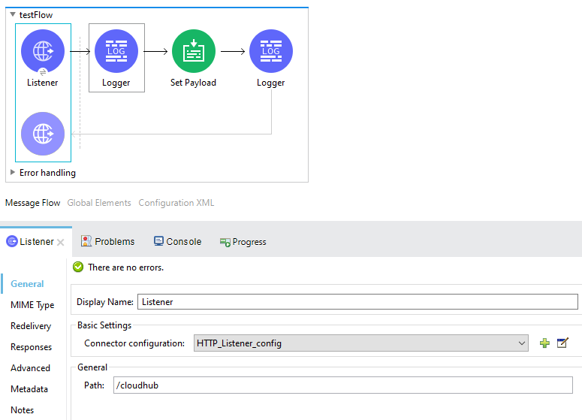

Pom.xml:

<?xml version=*"1.0"* encoding=*"UTF-8"*?>

<project xmlns=*"http://maven.apache.org/POM/4.0.0"* xmlns:xsi=*"http://www.w3.org/2001/XMLSchema-instance"*

xsi:schemaLocation=*"http://maven.apache.org/POM/4.0.0 http://maven.apache.org/maven-v4_0_0.xsd"*>

<modelVersion>4.0.0</modelVersion>

<groupId>com.mycompany</groupId>

<artifactId>cloudhub-deployments</artifactId>

<version>1.0.9-SNAPSHOT</version>

<packaging>mule-application</packaging>

<name>cloudhub-deployments</name>

<properties>

<project.build.sourceEncoding>UTF-8</project.build.sourceEncoding>

<project.reporting.outputEncoding>UTF-8</project.reporting.outputEncoding>

<app.runtime>4.2.2</app.runtime>

<mule.maven.plugin.version>3.3.5</mule.maven.plugin.version>

</properties>

<build>

<plugins>

<plugin>

<groupId>org.mule.tools.maven</groupId>

<artifactId>mule-maven-plugin</artifactId>

<version>${mule.maven.plugin.version}</version>

<extensions>true</extensions>

<configuration>

<cloudHubDeployment>

<uri>https://anypoint.mulesoft.com</uri>

<muleVersion>${app.runtime}</muleVersion>

<username>abc1234</username>

<password>XXXXXXXX</password>

<applicationName>cloudhub-demo-app</applicationName>

<environment>Sandbox</environment>

<workers>1</workers>

<workerType>Micro</workerType>

<region>us-east-1</region>

<businessGroup>89765</businessGroup>

<objectStoreV2>true</objectStoreV2>

</cloudHubDeployment>

</configuration>

</plugin>

</plugins>

</build>

<dependencies>

<dependency>

<groupId>org.mule.connectors</groupId>

<artifactId>mule-http-connector</artifactId>

<version>1.5.11</version>

<classifier>mule-plugin</classifier>

</dependency>

<dependency>

<groupId>org.mule.connectors</groupId>

<artifactId>mule-sockets-connector</artifactId>

<version>1.1.5</version>

<classifier>mule-plugin</classifier>

</dependency>

</dependencies>

<repositories>

<repository>

<id>anypoint-exchange-v2</id>

<name>Anypoint Exchange</name>

<url>https://maven.anypoint.mulesoft.com/api/v2/maven</url>

<layout>default</layout>

</repository>

<repository>

<id>mulesoft-releases</id>

<name>MuleSoft Releases Repository</name>

<url>https://repository.mulesoft.org/releases/</url>

<layout>default</layout>

</repository>

</repositories>

<pluginRepositories>

<pluginRepository>

<id>mulesoft-releases</id>

<name>mulesoft release repository</name>

<layout>default</layout>

<url>https://repository.mulesoft.org/releases/</url>

<snapshots>

<enabled>false</enabled>

</snapshots>

</pluginRepository>

</pluginRepositories>

<!—distributionManagement tags are related to Nexus OSS3.X set up-- >

<distributionManagement>

<repository>

<id>nexus</id>

<name>Releases</name>

<url>http://localhost:8081/nexus/content/repositories/releases</url>

</repository>

<snapshotRepository>

<id>nexus</id>

<name>Snapshot</name>

<url>http://localhost:8081/nexus/content/repositories/snapshots</url>

</snapshotRepository>

</distributionManagement>

</project>

## CloudHub deployment specific tags and explanation

<cloudHubDeployment>

<uri>https://anypoint.mulesoft.com</uri>

<muleVersion>${app.runtime}</muleVersion>

<username>abc1234</username>

<password>XXXXXXXX</password>

<applicationName>cloudhub-demo-app</applicationName>

<environment>Sandbox</environment>

<workers>1</workers>

<workerType>Micro</workerType>

<region>us-east-1</region>

<businessGroup>89765</businessGroup>

<objectStoreV2>true</objectStoreV2>

</cloudHubDeployment>

The following table shows the available parameters to configure the CloudHub deployment strategy in your project’s pom.xml file.

| **Parameter** | **Description** |
| --- | --- |
| cloudHubDeployment | Top-level element |
| uri | Your Anypoint Platform URI If not set, by default this value is set to https://anypoint.mulesoft.com. |
| muleVersion | The version of Mule that you want to run in your CloudHub instance Ensure that this value is equal to or later than the earliest required Mule version of your application. |
| username | Your CloudHub username |
| password | Your CloudHub password |
| applicationName | The name of your application in CloudHub This name is part of the domain of your deployed app. For example, naming your application  application-1 makes your app’s public domain application-1.cloudhub.io. |
| artifact | The absolute path of the JAR file to be deployed If not set, the path defaults to the location of the JAR file generated at the package phase. |
| environment | The CloudHub environment to which you want to deploy This value must match any environment configured in your CloudHub account.  <environment>Sandbox</environment> |
| properties | Top-Level element If you need to set properties for the Mule application you are deploying, you can use the   <properties> top-level element:  <properties>  <key>value</key>  </properties>  For example:  <properties>  <http.port>8081</http.port>  </properties> |
| workers | The number of workers By default, this value is 1. |
| workerType | Size of each worker; one of the following values:   * MICRO (default; 0.1 vCores) * SMALL (0.2 vCores) * MEDIUM (1 vCore ) * LARGE (2 vCores) * XLARGE (4 vCores) * XXLARGE (8 vCores) * 4XLARGE (16 vCores) |
| region | Region of worker clouds; one of the following values:   * us-east-1 (default; US East, N. Virginia) * us-east-2 (US East, Ohio) * us-west-1 (US West, N. California) * us-west-2 (US West, Oregon) * eu-central-1 (EU, Frankfurt) * eu-west-1 (EU, Ireland) * eu-west-2 (EU, London) * ap-southeast-1 (Asia Pacific, Singapore) * ap-southeast-2 (Asia Pacific, Sydney) * ap-northeast-1 (Asia Pacific, Tokyo) * ca-central-1 (Canada, Central) * sa-east-1 (South America, São Paulo) |
| objectStoreV2 | Enables Object Store V2 By default, it is set to false. |
| persistentQueues | Enables persistent queues By default, it is set to false. |
| businessGroup | The Business group path of the deployment For example:  <businessGroup>MasterOrg/SubOrg</businessGroup> |
| businessGroupId | The Business group id of the deployment This parameter is available in plugin version 3.2.7 and later. |
| deploymentTimeout | The allowed elapsed time, in milliseconds, between the start of the deployment process and  the confirmation that the artifact has been deployed  The default value is 1000000. |
| server | Maven server with Anypoint Platform credentials This is only needed if you want to use your credentials stored in your Maven settings.xml file.  This is not the Mule server name. |
| skip | When set to true, skips the plugin deployment goal. Its default value is false. |
| skipDeploymentVerification | When set to true, skips the status verification of your deployed app. Its default value is false. |
| authToken | Specifies the authorization token to access the platform. You can use this authentication method  instead of setting username and password. |
| connectedAppClientId | Specifies the Connected App clientID value. |
| connectedAppClientSecret | Specifies the Connected App secret key. |
| connectedAppGrantType | Specifies the only supported connection type: client_credentials. |
| applyLatestRuntimePatch | When set to true, the plugin instructs CloudHub to update the worker to the latest available  patch for the Mule runtime engine version specified in the deployment configuration, and  then deploys the application. By default, it is set to false. |

## Lets deploy the stuff to cloudhub

Open command prompt using Administrator Access and browse till the project location and use the maven deploy command as shown below:

C:\Users\Developer\AnypointStudio\studio-workspace\cloudhub-deployments>mvn clean package deploy -DmuleDeploy

[INFO] Scanning for projects...

[INFO]

[INFO] -----------------< com.mycompany:cloudhub-deployments >-----------------

[INFO] Building cloudhub-deployments 1.0.9-SNAPSHOT

[INFO] --------------------------[ mule-application ]--------------------------

[INFO]

[INFO] --- maven-clean-plugin:2.5:clean (default-clean-1) @ cloudhub-deployments ---

[INFO] Deleting C:\Users\Developer\AnypointStudio\studio-workspace\cloudhub-deployments\target

[INFO]

[INFO] --- mule-maven-plugin:3.3.5:clean (default-clean) @ cloudhub-deployments ---

[INFO]

[INFO] --- maven-clean-plugin:2.5:clean (default-clean) @ cloudhub-deployments ---

[INFO]

[INFO] --- mule-maven-plugin:3.3.5:validate (default-validate) @ cloudhub-deployments ---

[INFO]

[INFO] --- mule-maven-plugin:3.3.5:initialize (default-initialize) @ cloudhub-deployments ---

[INFO]

[INFO] --- mule-maven-plugin:3.3.5:generate-sources (default-generate-sources) @ cloudhub-deployments ---

[INFO]

[INFO] --- mule-maven-plugin:3.3.5:process-sources (default-process-sources) @ cloudhub-deployments ---

[INFO] About to fetch required dependencies for artifact: com.mycompany:cloudhub-deployments:pom:1.0.9-SNAPSHOT. This may take a while...

[INFO]

[INFO] --- maven-resources-plugin:3.0.2:resources (default-resources) @ cloudhub-deployments ---

[INFO] Using 'UTF-8' encoding to copy filtered resources.

[INFO] Copying 2 resources

[INFO]

[INFO] --- mule-maven-plugin:3.3.5:process-resources (default-process-resources) @ cloudhub-deployments ---

[INFO]

[INFO] --- maven-compiler-plugin:3.8.0:compile (default-compile) @ cloudhub-deployments ---

[INFO] Nothing to compile - all classes are up to date

[INFO]

[INFO] --- mule-maven-plugin:3.3.5:compile (default-compile) @ cloudhub-deployments ---

[INFO]

[INFO] --- mule-maven-plugin:3.3.5:process-classes (default-process-classes) @ cloudhub-deployments ---

[INFO]

[INFO] --- mule-maven-plugin:3.3.5:generate-test-sources (default-generate-test-sources) @ cloudhub-deployments ---

[INFO]

[INFO] --- maven-resources-plugin:3.0.2:testResources (default-testResources) @ cloudhub-deployments ---

[INFO] Using 'UTF-8' encoding to copy filtered resources.

[INFO] Copying 1 resource

[INFO]

[INFO] --- mule-maven-plugin:3.3.5:generate-test-resources (default-generate-test-resources) @ cloudhub-deployments ---

[INFO]

[INFO] --- maven-compiler-plugin:3.8.0:testCompile (default-testCompile) @ cloudhub-deployments ---

[INFO] Nothing to compile - all classes are up to date

[INFO]

[INFO] --- mule-maven-plugin:3.3.5:test-compile (default-test-compile) @ cloudhub-deployments ---

[INFO]

[INFO] --- maven-surefire-plugin:2.19.1:test (default-test) @ cloudhub-deployments ---

[INFO]

[INFO] --- mule-maven-plugin:3.3.5:package (default-package) @ cloudhub-deployments ---

[INFO] Building zip: C:\Users\Developer\AnypointStudio\studio-workspace\cloudhub-deployments\target\cloudhub-deployments-1.0.9-SNAPSHOT-mule-application.jar

[INFO]

[INFO] --- mule-maven-plugin:3.3.5:validate (default-validate) @ cloudhub-deployments ---

[INFO]

[INFO] --- mule-maven-plugin:3.3.5:initialize (default-initialize) @ cloudhub-deployments ---

[INFO]

[INFO] --- mule-maven-plugin:3.3.5:generate-sources (default-generate-sources) @ cloudhub-deployments ---

[INFO]

[INFO] --- mule-maven-plugin:3.3.5:process-sources (default-process-sources) @ cloudhub-deployments ---

[INFO]

[INFO] --- maven-resources-plugin:3.0.2:resources (default-resources) @ cloudhub-deployments ---

[INFO] Using 'UTF-8' encoding to copy filtered resources.

[INFO] Copying 2 resources

[INFO]

[INFO] --- mule-maven-plugin:3.3.5:process-resources (default-process-resources) @ cloudhub-deployments ---

[INFO]

[INFO] --- maven-compiler-plugin:3.8.0:compile (default-compile) @ cloudhub-deployments ---

[INFO] Nothing to compile - all classes are up to date

[INFO]

[INFO] --- mule-maven-plugin:3.3.5:compile (default-compile) @ cloudhub-deployments ---

[INFO]

[INFO] --- mule-maven-plugin:3.3.5:process-classes (default-process-classes) @ cloudhub-deployments ---

[INFO]

[INFO] --- mule-maven-plugin:3.3.5:generate-test-sources (default-generate-test-sources) @ cloudhub-deployments ---

[INFO]

[INFO] --- maven-resources-plugin:3.0.2:testResources (default-testResources) @ cloudhub-deployments ---

[INFO] Using 'UTF-8' encoding to copy filtered resources.

[INFO] Copying 1 resource

[INFO]

[INFO] --- mule-maven-plugin:3.3.5:generate-test-resources (default-generate-test-resources) @ cloudhub-deployments ---

[INFO]

[INFO] --- maven-compiler-plugin:3.8.0:testCompile (default-testCompile) @ cloudhub-deployments ---

[INFO] Nothing to compile - all classes are up to date

[INFO]

[INFO] --- mule-maven-plugin:3.3.5:test-compile (default-test-compile) @ cloudhub-deployments ---

[INFO]

[INFO] --- maven-surefire-plugin:2.19.1:test (default-test) @ cloudhub-deployments ---

[INFO] Skipping execution of surefire because it has already been run for this configuration

[INFO]

[INFO] --- mule-maven-plugin:3.3.5:package (default-package) @ cloudhub-deployments ---

[INFO]

[INFO] --- mule-maven-plugin:3.3.5:verify (default-verify) @ cloudhub-deployments ---

[INFO]

[INFO] --- maven-install-plugin:2.5.2:install (default-install) @ cloudhub-deployments ---

[INFO] No primary artifact to install, installing attached artifacts instead.

[INFO] Installing C:\Users\Developer\AnypointStudio\studio-workspace\cloudhub-deployments\pom.xml to C:\Users\Developer\.m2\repository\com\mycompany\cloudhub-deployments\1.0.9-SNAPSHOT\cloudhub-deployments-1.0.9-SNAPSHOT.pom

[INFO] Installing C:\Users\Developer\AnypointStudio\studio-workspace\cloudhub-deployments\target\cloudhub-deployments-1.0.9-SNAPSHOT-mule-application.jar to C:\Users\Developer\.m2\repository\com\mycompany\cloudhub-deployments\1.0.9-SNAPSHOT\cloudhub-deployments-1.0.9-SNAPSHOT-mule-application.jar

[INFO]

[INFO] --- mule-maven-plugin:3.3.5:deploy (default-deploy) @ cloudhub-deployments ---

[INFO] Deploying artifact cloudhub-demo-app

[INFO] Creating application: cloudhub-demo-app

[INFO] Starting application: cloudhub-demo-app

[INFO] Checking if application: cloudhub-demo-app has started

[INFO] Artifact cloudhub-demo-app deployed

[INFO] ------------------------------------------------------------------------

[INFO] BUILD SUCCESS

[INFO] ------------------------------------------------------------------------

[INFO] Total time: 01:33 min

[INFO] Finished at: 2020-04-23T20:16:50+05:30

[INFO] ------------------------------------------------------------------------

## How it looks in CloudHub ?

Login to Anypoint.mulesoft.com using credentials (same as used in pom.xml). Point towards RuntimeManager-> Applications

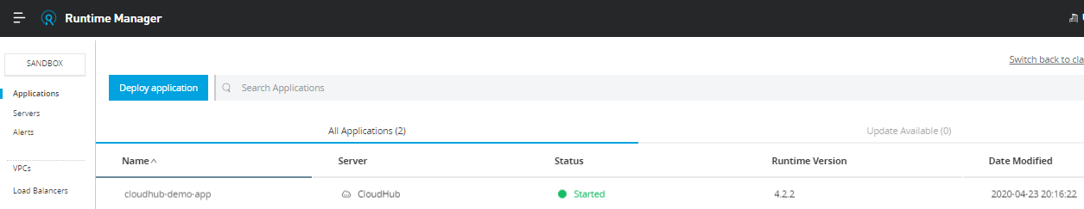

## Try it with postman

Click on Applications -> cloudhub-demo-app

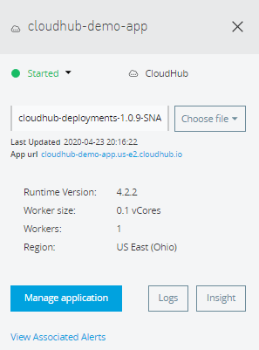

Copy the App url to PostMan with path configured in HTTP listener: “/cloudhub” and hit “Send”

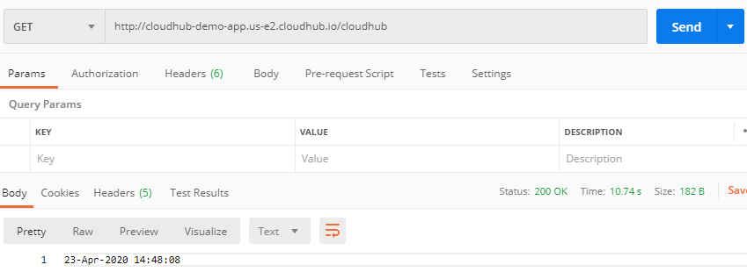

## Fair enough? Lets check out the logs

Click to Runtime manager->Applications-> “cloudhub-demo-app” -> Logs

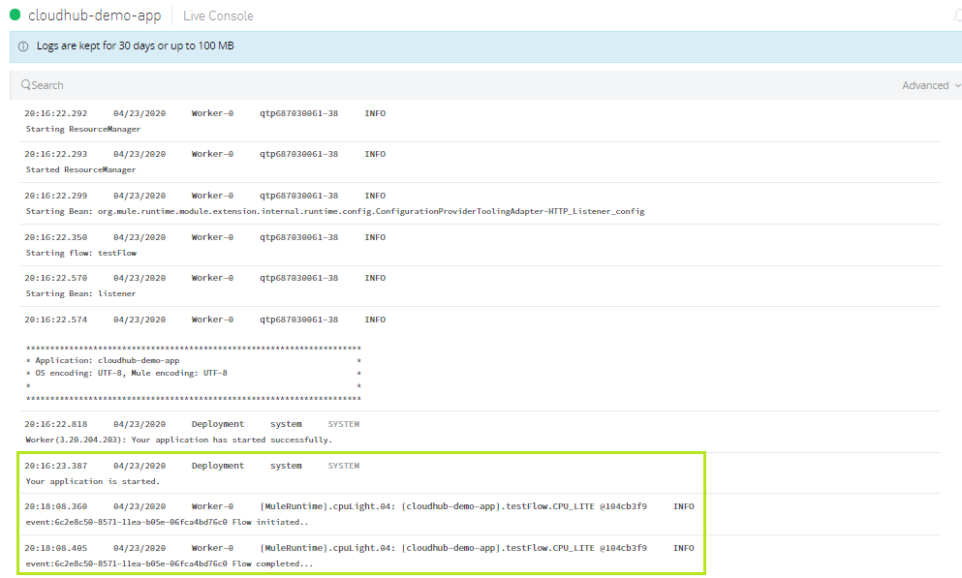

## What next?

1. Check for properties file to externalize the different build and other configurations
2. Possible encryption of credentials? Secure properties
3. Anypoint Platform capabilities :
4. Dashboard

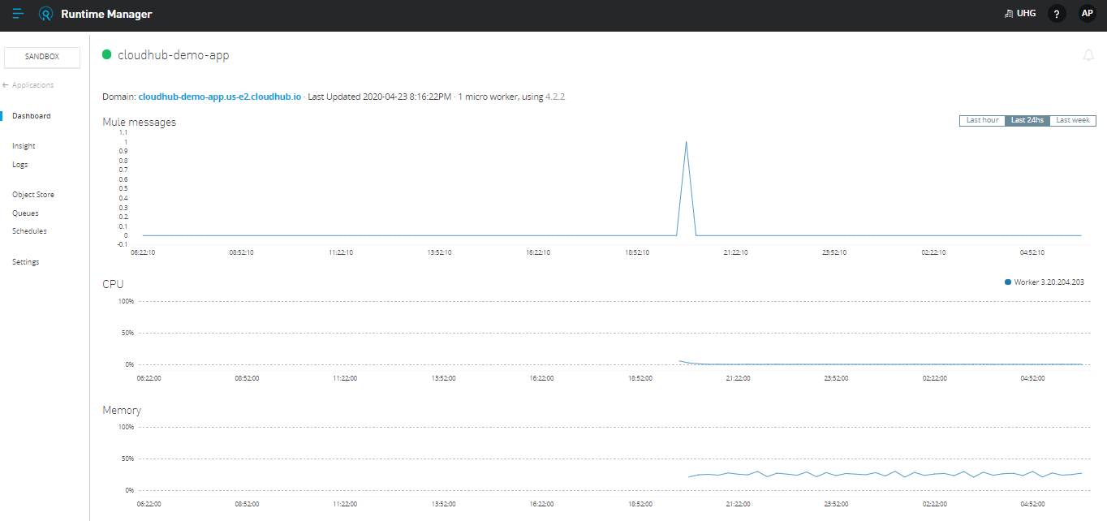

1. Settings

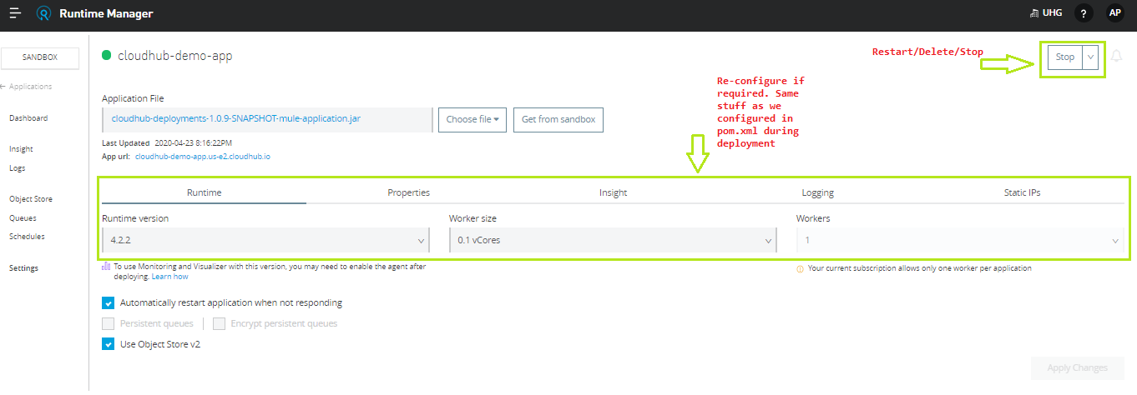

1. Settings.xml



1. ARM deployment details: <https://github.com/ancur4u/ARMDeployments>